MEDIA CONTACT:
Michelle Callahan
Future Chefs
978-758-2397
michelle@futurechefs.net

Alison Harding
Cummings Foundation
781-932-7093 aeh@cummings.com

FUTURE CHEFS AWARDED $400,000 CUMMINGS GRANT
Roxbury nonprofit receives 10 years of funding from Cummings Foundation

FOR IMMEDIATE RELEASE
Roxbury, June 5, 2023 – Future Chefs is one of 150 local nonprofits that will share in $30 million through Cummings Foundation’s major annual grants program. The Roxbury-based organization was selected from a total of 630 applicants during a competitive review process. It will receive $400,000 over 10 years.
Founded in 2008 by Executive Director Toni Elka, Future Chefs was seeded by Toni’s idea that every young person should be able to imagine a purposeful, joyful future and that our society has a collective obligation to prepare young people for the adult world of work and life. Over the last decade, the organization has become a leader in supporting teens to find a path to economic security. Teens develop knife skills and life skills while engaged in the kitchen. In 2020, Future Chefs completed its long-term strategic goal of moving to Roxbury to become a community-based organization, evolving from just a youth program to a center of community empowerment. As Future Chefs becomes embedded in this neighborhood, it is expanding its reach to serve as a hub of positive and nurturing activity in the Grove Hall area of Roxbury.
“We are so grateful for the significant investment Cummings Foundation has made in Future Chefs. We wanted to create a gathering space for the community, a launching pad, and an active environment where young people can breathe life into plans for their futures,” said Future Chefs Executive Director Toni Elka. “We envision our graduates pursuing a plan for their education, with strategies for addressing systems of privilege and power, and a network of support and guidance to see them through. This long term investment signals to the community at large that Future Chefs has a permanent home in Roxbury.”
Moving to Blue Hill Avenue in Roxbury created an opportunity for Future Chefs to grow its program. To support this work, Future Chefs will use the 10-year gift from the Cummings Foundation to develop its community engagement initiative. Future Chefs will expand its daytime work with Boston Public Schools to provide an additional learning space where youth earn wages and credits, as they gain important skills to prepare them for the workplace. Additionally, Future Chefs will become a meeting place for local organizations to work toward their collective goal of community empowerment. This work contributes to the vibrancy of the neighborhood and Future Chefs will become a place to deepen these connections.
The Cummings $30 Million Grant Program primarily supports Massachusetts nonprofits that are based in and serve Middlesex, Essex, and Suffolk counties. Through this place-based initiative, Cummings Foundation aims to give back in the areas where it owns commercial property. Its buildings are all managed, at no cost to the Foundation, by its affiliate, Cummings Properties. This Woburn-based commercial real estate firm leases and manages 11 million square feet of debt-free space, the majority of which exclusively benefits the Foundation.
“The way the local nonprofit sector perseveres, steps up, and pivots to meet the shifting needs of the community is most impressive,” said Cummings Foundation executive director Joyce Vyriotes. “We are incredibly grateful for these tireless efforts to support people in the community and to increase equity and access to opportunities.”
The majority of the grant decisions were made by about 90 volunteers. They worked across a variety of committees to review and discuss the proposals and then, together, determine which requests would be funded. Among these community volunteers were business and nonprofit leaders, mayors, college presidents, and experts in areas such as finance and DEI (diversity, equity, and inclusion).
“It would not be possible for the Foundation to hire the diversity and depth of expertise and insights that our volunteers bring to the process,” said Vyriotes. “We so appreciate the substantial time and thought they dedicated toward ensuring that our democratized version of philanthropy results in equitable outcomes that will really move the needle on important issues in local communities.”
The Foundation and volunteers first identified 150 organizations to receive three-year grants of up to $225,000 each. The winners included first-time recipients as well as nonprofits that had previously received Cummings grants. Twenty-five of this latter group of repeat recipients were then selected by a volunteer panel to have their grants elevated to 10-year awards ranging from $300,000 to $1 million each.
This year’s grant recipients represent a wide variety of causes, including housing and food insecurity, workforce development, immigrant services, social justice, education, and mental health services. The nonprofits are spread across 46 different cities and towns.
Cummings Foundation has now awarded $480 million to greater Boston nonprofits. The complete list of this year’s 150 grant winners, plus nearly 1,500 previous recipients, is available at www.CummingsFoundation.org.
Future Chefs is proud to be a Fiscally Sponsored Organization of Third Sector New England (TSNE).
# # #

About Future Chefs
Future Chefs empowers Boston youth to take charge of their future by providing opportunities to lead and to develop the skills needed to grow in their personal and professional life beyond high school. We address the injustices of systemic racism by supporting Boston’s youth of color to develop essential job and life skills while engaged in authentic, productive work in our kitchen, a medium in which teens are inspired and challenged. Our program supports teens to (1) explore culinary and job-readiness skills, (2) earn and learn in paid work-based employment while practicing the skills they will need in any career, and (3) work their plan for after high school with coaching and support from the staff.
Our headquarters on Blue Hill Avenue brings a state-of-the-art production and teaching kitchen and community resource to Roxbury. With this hub, Future Chefs will provide food for the community, employ more students, and provide positive youth space and career support services for teens and their families. Visit www.futurechefs.net for more information.
# # #
About Cummings Foundation
Woburn-based Cummings Foundation, Inc. was established in 1986 by Joyce and Bill Cummings of Winchester, MA and has grown to be one of the largest private foundations in New England. The Foundation directly operates its own charitable subsidiaries, including New Horizons retirement communities, in Marlborough and Woburn, and Cummings Health Sciences, LLC. Additional information is available at www.CummingsFoundation.org.
# # #
Young people are earning and learning in the Future Chefs production and teaching kitchen.
Photo credit Jane Messinger

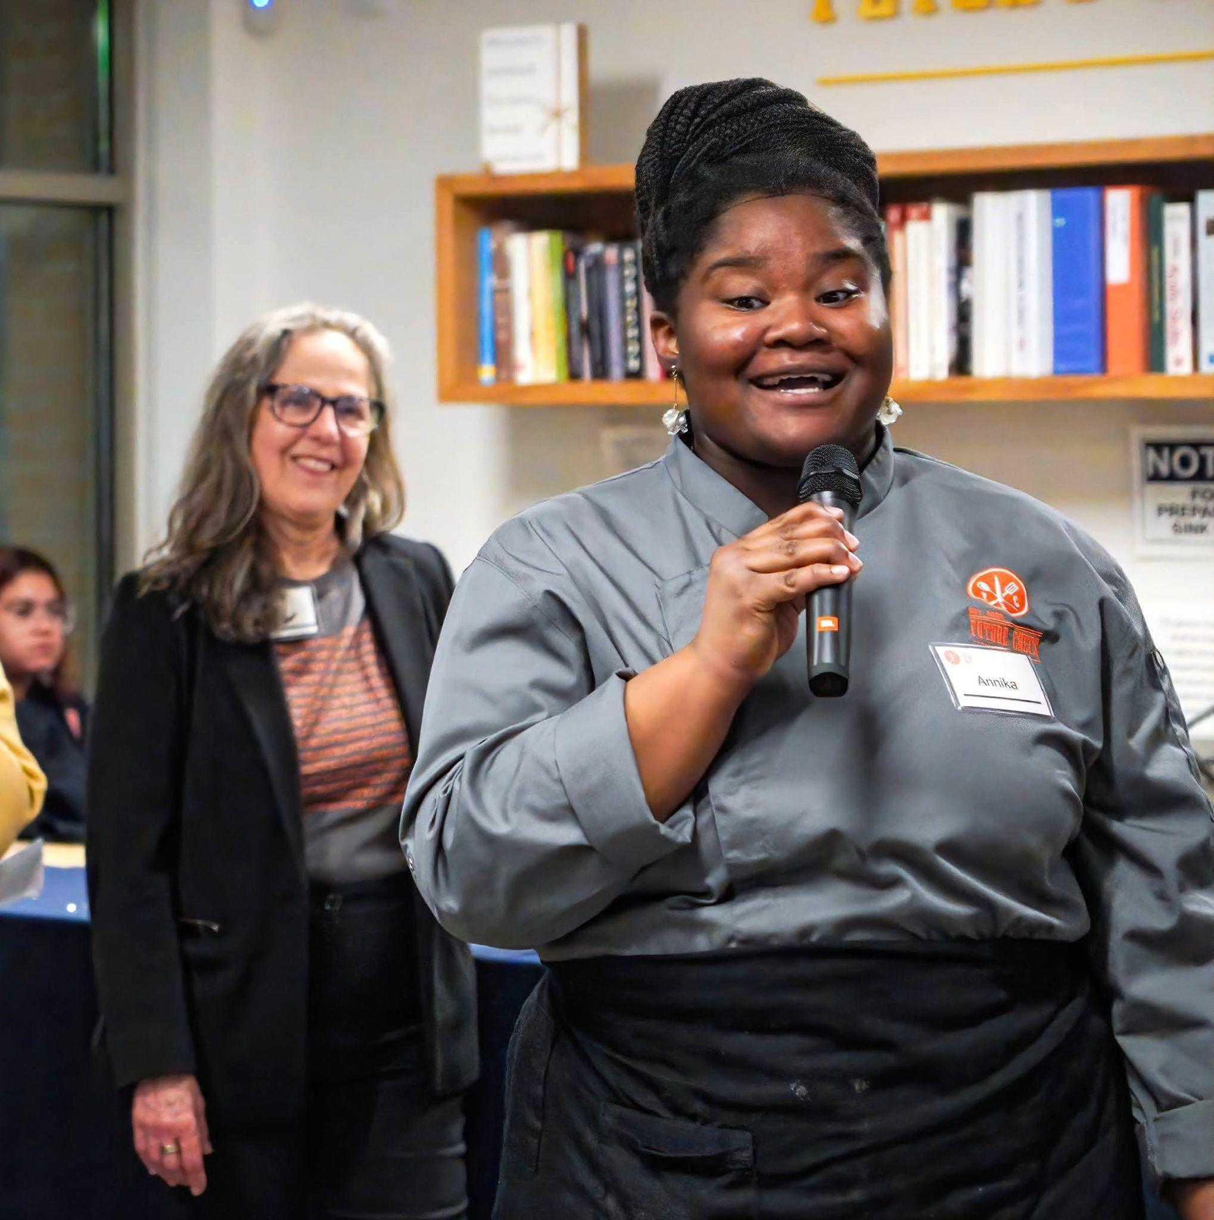
Students at Future Chefs practice essential life and career skills such as public speaking and leadership.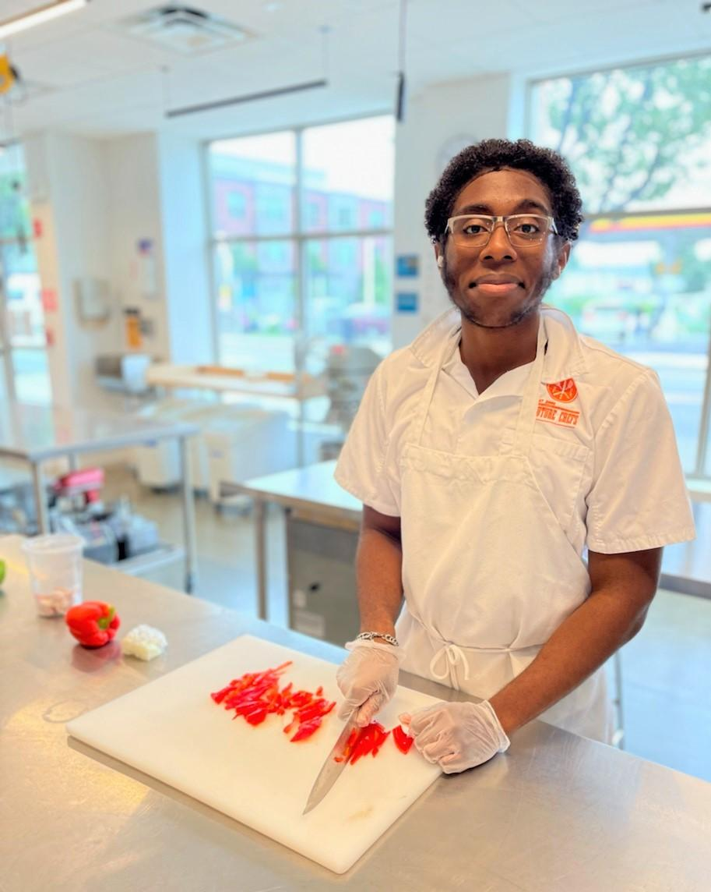
Youth are engaged in the kitchen while practicing knife skills and life skills.

